**Role**

This section allows Users to create, modify, and remove roles specific to the selected Project.

**Project Role Details**

The button labeled "+ Role" enables the user to create new roles at the selected project level. After navigating to the "Roles" tab in the Project menu section, the user will be able to view the Roles List.

**Navigation**

**Project Selection > Projects Tab > Roles**

**Note**: Roles created at the All Project level can be used at the Individual Project level, but roles created at the Individual Project level cannot be utilized at the All Project level.

**“Create Role” Pop-Up Details**

Controlling the accessibility of specific Projects is crucial, and this is where the module section comes into play. The module section comprises different modules, including Dashboard, Analytics, Repository, Test Data, Test Development, Execution, Defects, and Configuration. These modules are significant in determining the accessibility of a particular Project.

**Three fields will appear in the Create Role pop-up:**

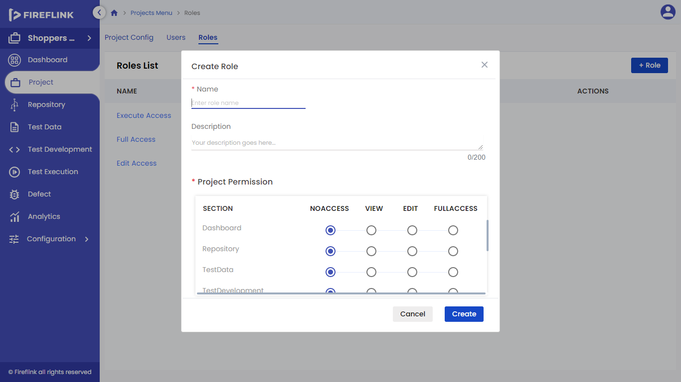

* **Name:** This field requires the role name, which is mandatory.
* **Description:** The user can provide a description for the created role
* **Project Permission Table:** The project permission table allows users to select the level of access for different modules, including No Access, View, Edit, and Full Access.

**Steps to Create a Role**

* Click on the +Role Button. Create Role Pop-up will be displayed.
* Fill in the Mandatory Fields — Name, Project Permission. The description is Non-Mandatory.
* Click on Create Button.
* Created Role is displayed in the Role List.

**Roles List**

**The roles list contains four fields as follows:**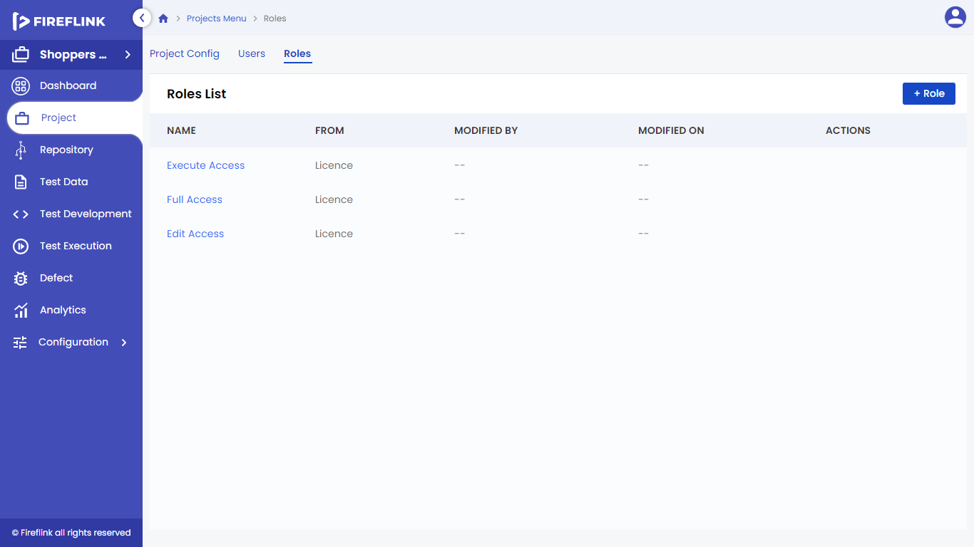

* **Name**: The name of the role that is hyperlinked to the role details pop-up. From column displays the license role and project role if they are created from the All Project level and Individual Project level respectively.
* **Modified by**: The name of the user who has modified the project is hyperlinked to the user details.
* **Modified On**: The updated time of the Role along with the date is recorded.
* **Actions**: This field is not displayed automatically.

The user has to hover the cursor over the particular user to see the options under the actions column:

* **Edit**: All fields here are editable. Users can modify it according to their requirements.
* **Delete**: The user cannot delete the Role which is in use i.e. which is assigned to any user. o
* **More**: Users can utilize this functionality for one utility:
* **Details**: Role details are displayed.

**“Role Details” Pop-Up**

The role details pop-up consists of all the data that has been provided during the Role creation. 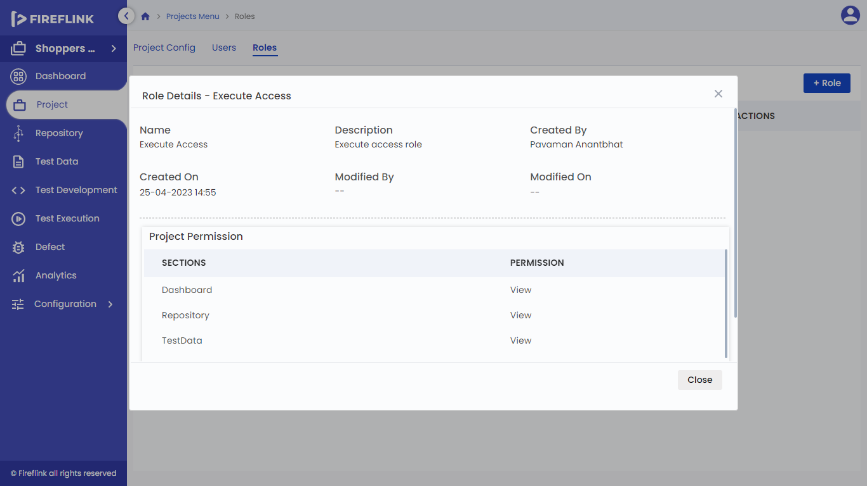

* **Name**: role name provided during role creation will be displayed.
* **Description**: Description provided during role creation will be displayed.
* **Created by:** Name of the user who created the Role will be displayed.
* **Created on:** Date and time on which the project is created will be recorded.
* **Modified by:** Name of the user who modified the Role will be displayed.
* **Modified on:** Date and time on which changes are made will be displayed.
* **Project Permission:** This table is displayed in which the user can see the provided accessibilities for each section.